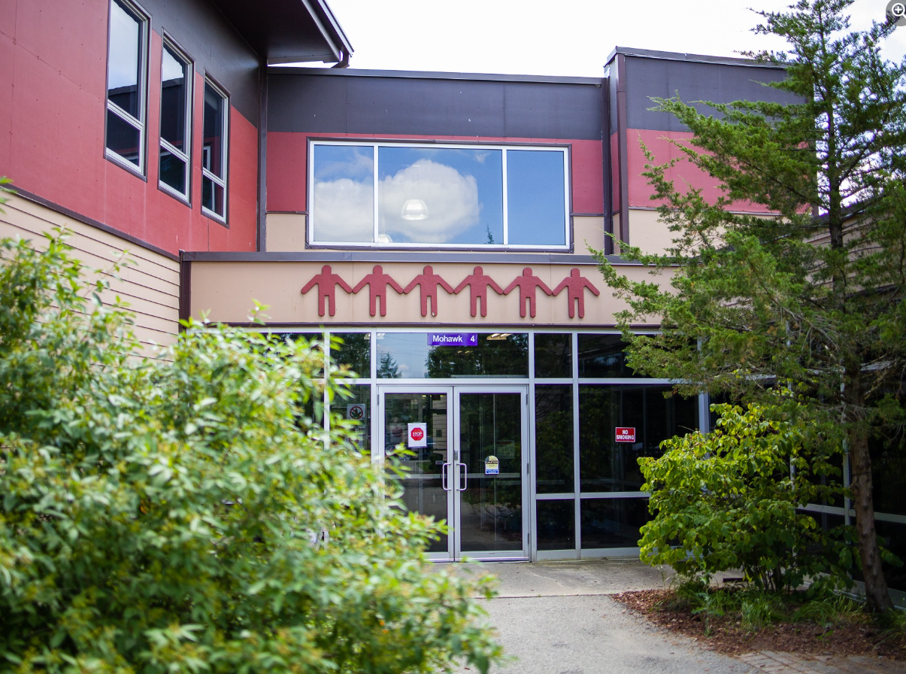
Grand River Employment and Training Inc. (GRETI) is seeking a Cultural Support to promote and support Haudenosaunee cultural awareness through programming, workshops, and community engagement
Cultural Support
Two (2) Part Time Position’s Available
Salary Range: $31,500- $39,700

The Cultural Support shall possess the following skills: Customer Focus, Communication, Problem Solving. In addition to these skills, you must possess the following qualifications:
Qualifications:
- Diploma or currently enrolled to Indigenous Studies or a Haudenosaunee Language, or Business Administration
- Minimum one (1) to three (3) years’ experience in cultural teachings or workshop facilitation or office administration

If you have desire to promote, preserve, and share Haudenosaunee culture, traditions, and knowledge, tell us who you are by submitting the following:
- Cover letter stating how you meet the demands of this position
- Up to Date Resume highlighting your qualifications, and
- Three (3) work related references (letters not required)
Please submit a covering letter and resume that demonstrates how you meet the requirements, GRETI cannot make assumptions about your education and experience. We thank all those who apply.
GRETI offers a competitive wage, group benefits and pension for full time employees, three (3) weeks’ vacation to start, along with other non-required benefits
Applications must be submitted to: Human Resources, P.O. Box 69, 16 Sunrise Court, Ohsweken, Ontario N0A 1M0
Applications may also be faxed and emailed to (Fax) (519) 445-4777 or kristen@gretisn.org until 4:00 PM on Friday, May 8, 2026.
GRETI is committed to providing an inclusive and barrier-free work environment, starting with the hiring process. If you are contacted by GRETI regarding a job opportunity, please advise if you have any restrictions that need to be accommodated. All information received in relation to accommodation will be kept confidential. Based on the need to provide professional services, only those applicants meeting the minimum qualifications will be contacted for an interview.

Job Title: | Cultural Support
Location: | OSTTC/Longhouse
Reports To: | Programs Team Lead

A. PURPOSE:
The Cultural Support is responsible for promoting cultural awareness through the development and delivery of programs and workshops for OSTTC students and the broader community. Working in collaboration with the Cultural Specialist, this role engages with community members, Elders, organizations, and government agencies to support the preservation and revitalization of Haudenosaunee culture.

In addition, the Cultural Support contributes to curriculum development and program delivery, while identifying community needs and providing educational resources and workshops to schools, organizations, and the public.

The Cultural Support is responsible for assisting the department and organization in reaching their goals and objectives by continuously enhancing operations through more efficient and effective work processes while maintaining the level of professionalism expected by GRETI (as outlined in the Policies and Procedures Manuals) and upholding the ethics of the position.

B. CORE COMPETENCIES:
- Customer Focus  - Communication  - Problem Solving | - Analysis  - Planning & organizing
C. QUALIFICATIONS:
The Cultural Support shall possess Diploma in Education or Continuing Education, in relation to Indigenous Studies or a Haudenosaunee Language, or Business Administration with a Minimum one (1) to three (3) years’ experience in tourism &/or office administration.

Knowledge
- Must have clear understanding of Haudenosaunee culture
- Strong desire to preserve Haudenosaunee languages and culture is a requirement
- Knowledge of at least 1 (or more) Haudenosaunee languages is an asset
- Public Outreach

Skills
- Weekend Availability, Flexible Days
- Willingness to work with the General Public in a respectful manner
- Willingness to work overtime to meet deadlines
- Ability to take direction and be a team player
- Excellent interpersonal communication skills
FOR A COMPLETE COPY OF THE JOB DESCRIPTION, PLEASE CONTACT HUMAN RESOURCES at kristen@gretisn.org, please allow 24 hours for a return
e-mail or call (519) 445-2222 ext. 3113.

We use artificial intelligence tools to support the screening, assessment, and selection of applicants in our GRETI hiring process. These tools assist our team and do not replace human decision-making.

