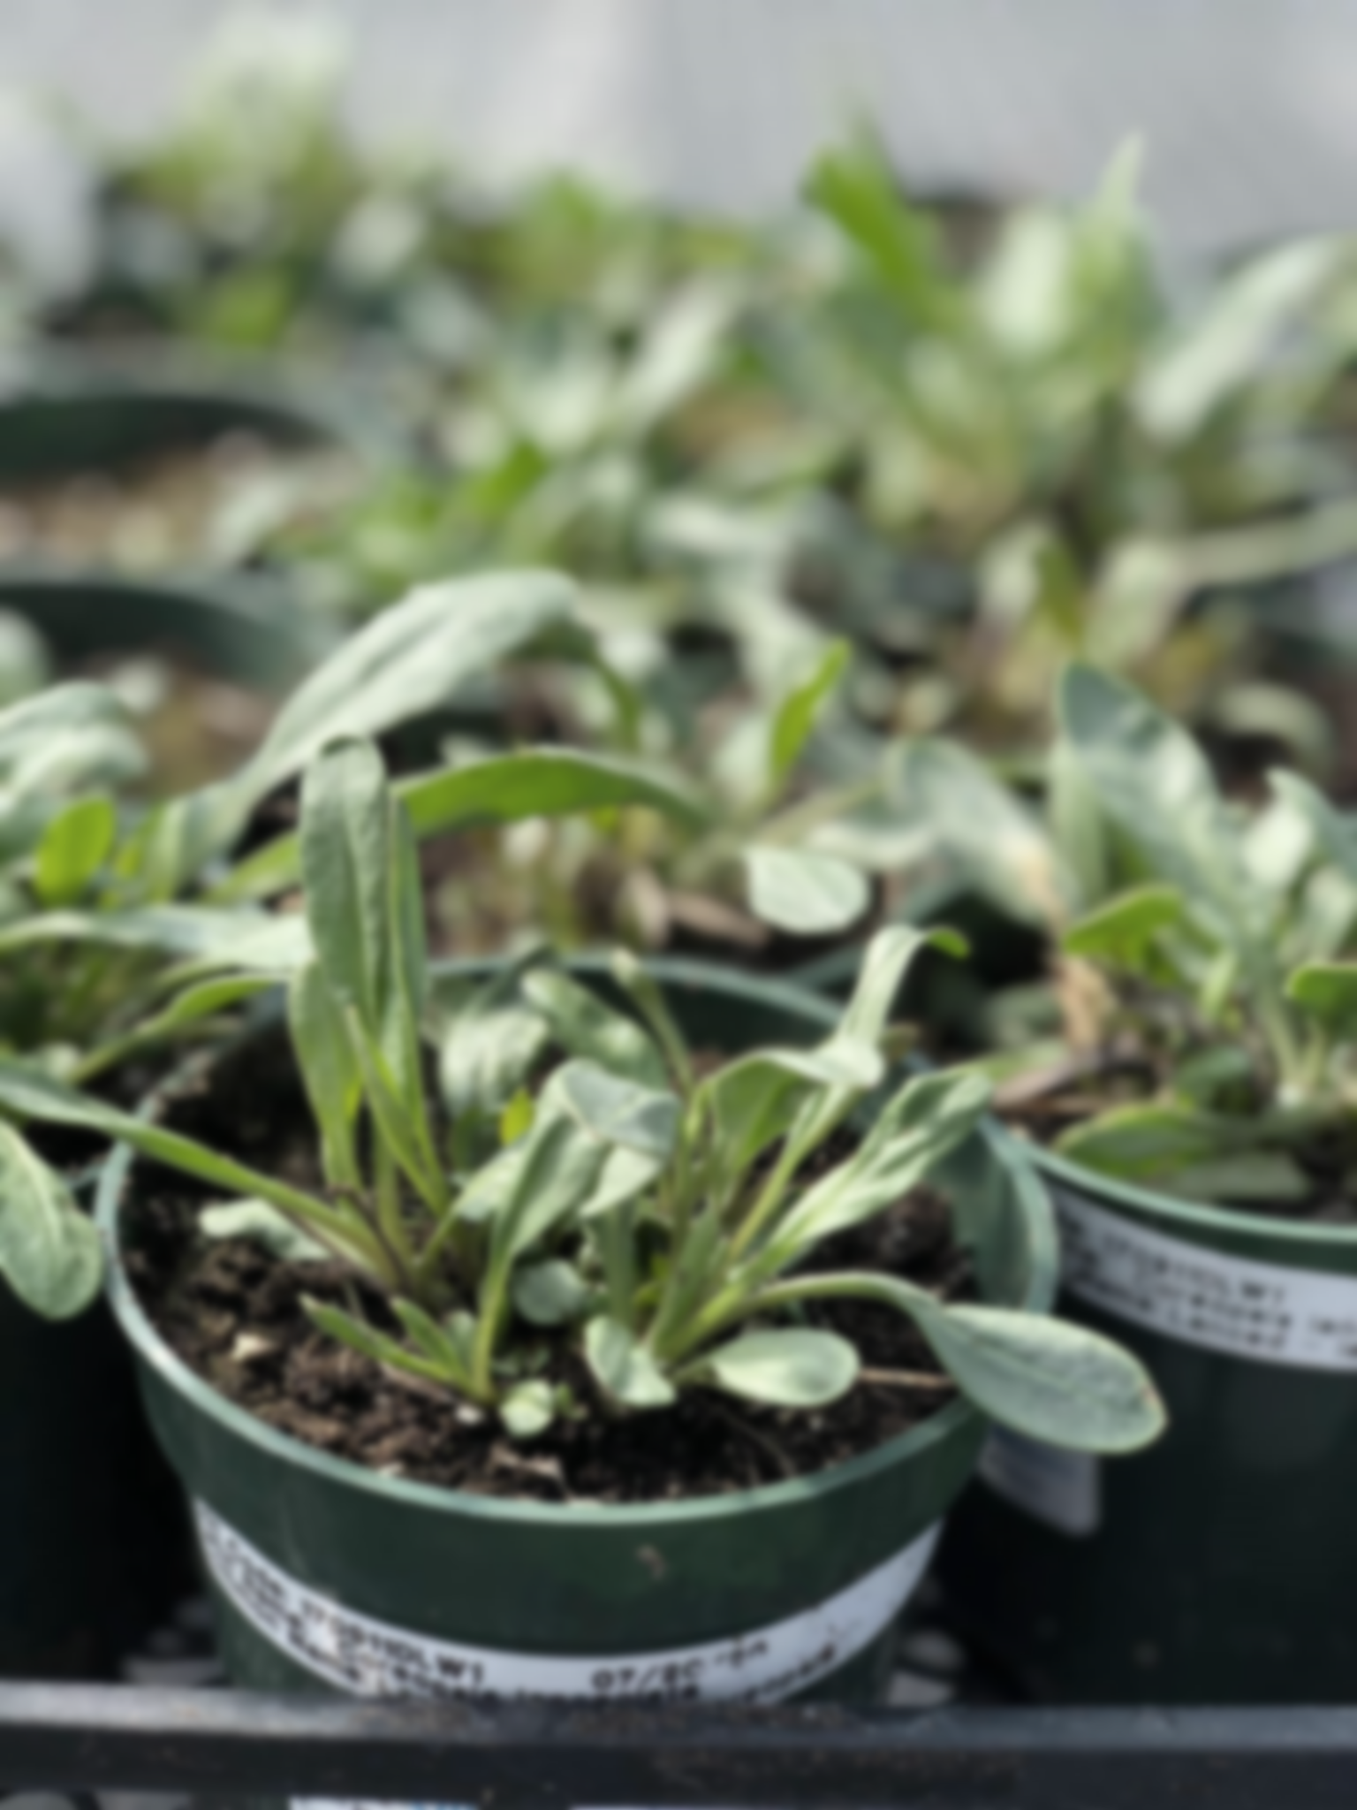
Grand River Employment and Training Inc. (GRETI) is seeking a Plant Production Team Lead to oversee daily propagation, production, and inventory of native Carolinian plant species at the Kayanase native plant nursery. The role supports efficient nursery operations, coordinates team activities, and upholds GRETI’s professional standards, policies, and organizational goals.
Plant Production Team Lead
One (1) 6-Month Fixed Term Position Available
Salary Range: $53,600 - $75,000

- The Plant Production Team Lead shall possess the following skills: Accountability, Creative & Analytical Thinking, Critical Thinking, Communication. In addition to these skills, you must possess the following qualifications:

Qualifications:
- Diploma in Horticulture or Nursery Production, Agriculture, Ecology, or related discipline
- Three (3) to five (5) years of experience in horticulture/nursery production & supervision
If you have a strong desire to help the native environment thrive, tell us who you are by submitting the following:
- Cover letter stating how you meet the demands of this position
- Up to Date Resume highlighting your qualifications, and
- Three (3) work-related references (letters not required)
Kayanase’s Mission: is to restore the health and beauty of Mother Earth, using science-based approaches and Traditional Ecological Knowledge (TEK).

Please submit a covering letter and resume that demonstrates how you meet the requirements, GRETI cannot make assumptions about your education and experience. We thank all those who apply. Only those selected for further consideration will be contacted
Applications may be submitted to: Human Resources, P.O Box 69, Sunrise Court, Ohsweken, Ontario N0A 1M0
Applications may also be faxed and emailed to (Fax) (519) 445-4777 or kristen@gretisn.org open until filled.
GRETI is committed to providing an inclusive and barrier-free work environment, starting with the hiring process. If you are contacted by GRETI regarding a job opportunity, please advise if you have any restrictions that need to be accommodated. All information received in relation to accommodation will be kept confidential. Please note that this position is a 6-month contract to cover a leave of absence with possibility of extension. Based on the need to provide professional services, only those applicants meeting the minimum qualifications will be contacted for an interview.
Job Title: | Plant Production Team Lead
Location: | Kayanase Greenhouse
Reports To: | Kayanase Operations Manager

A. PURPOSE
The Plant Production Team Lead is responsible for overseeing daily propagation activities, production, and inventory of native Carolinian plant species, including trees, shrubs, grasses, and herbaceous plants, at the Kayanase native plant nursery.

The Plant Production Team Lead continuously strives to improve operations and streamline work processes through efficient and effective service coordination, team commitment and the achievement of organizational goals and objectives while maintaining the level of professionalism expected by GRETI (as outlined in the Policies and Procedures Manuals) and upholding the ethics of the position.

B. CORE COMPETENCIES:
- Accountability  - Creative & Analytical Thinking  - Critical Thinking  - Communication | - Planning & Organizing  - Problem Solving  - Results Orientation
C. QUALIFICATIONS:
The Plant Production Team Lead shall possess Diploma in Horticulture or Nursery Production, Agriculture, Ecology, or related discipline with a Three (3) to five (5) years of experience in horticulture/nursery production & supervision
Knowledge
- Knowledge of native plant taxonomy & plant identification, specific to Carolinian zone
- Familiarity with concepts of Traditional Ecological Knowledge
- Working knowledge of relevant computer software programs including Microsoft Word, Excel, & Outlook
- Knowledge of WHMIS

Skills
- Ability to lift objects up to 40 pounds e.g., bags of soil
- Good interpersonal & communication skills
- Willingness to work overtime, including weekends to meet deadlines
- Good analytical and problem-solving skills

FOR A COMPLETE COPY OF THE JOB DESCRIPTION, PLEASE CONTACT HUMAN RESOURCES at kristen@gretisn.org, please allow 24 hours for a return
e-mail or call (519) 445-2222 ext. 3113.
We use artificial intelligence tools to support the screening, assessment, and selection of applicants in our GRETI hiring process. These tools assist our team and do not replace human decision-making.

