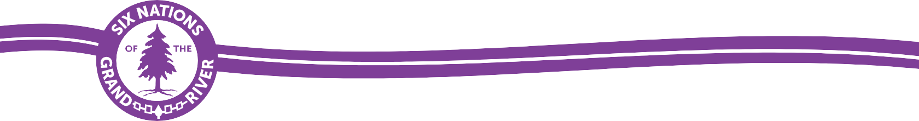

DIETITIAN – 019R1-25-1
Community Health and Wellness, Wellbeing
Full-Time

Applications will be received by Six Nations of the Grand River and Grand River Employment & Training (GREAT) up until 4:00 p.m. EST, Wednesday, May 14, 2025, for the Dietitian with Community Health and Wellness, Wellbeing. The Six Nations of the Grand River Application for Employment Form, Job Posting, and Job Description are available for printing from the www.greatsn.com website. Online applications are accepted through My Job Search. NO LATE APPLICATIONS ACCEPTED.

Applicants from Six Nations and other First Nations will be given preference to deliver programs and services in a First Nations community.

JOB SUMMARY: The Dietitian reports to and receives direct supervision from the
Team Supervisor, Community Health and Wellness, Six Nations of the Grand River Elected Council. Receives clinical day-to-day supervision from the Clinical Lead.

PURPOSE AND SCOPE OF THE POSITION:
To develop and implement nutrition and diabetes promotion programs for the Six Nations Community with the emphasis of promoting wellness and the maintenance of healthy lifestyles through a complete consultative approach while working within the administrative procedures established for this position.

Type | Full Time
Closing Date | May 14, 2025
Hours of Work | 35hrs/week
Wage | Minimum $70,400/year

*A competitive compensation package will be offered commensurate with qualifications. *

BASIC QUALIFICATIONS:
Bachelor of Science in Nutritional Science with experience in community nutrition preferred.
Member or eligible for membership with the Ontario College of Dietitians. Certified Diabetes Educator, preferred
Good knowledge, preferable gained through related experience and training in the delivery of nutrition services.
CPR and First Aid certificate preferred
High level of computer skills of Microsoft Office, MS Word, Excel High level of sensitivity to Native issues
Exhibits a high degree of initiative and self-direction; good analytical, organizational, verbal and written communication skills.
Good background in research; ability to conceptualize
Ability to work with tact and discretion; high level of public relation skills and good project management skills.

SUBMISSION PROCEDURE: (Choose one method ONLY):

Method #1: Online
- Please visit: My Job Search to access our job board and follow the directions to apply.
- Please ensure all required documents are provided/uploaded with your application package, which includes:
  - Cover letter including your band name and number (if applicable). Please indicate in your letter how your education and experience qualify you for this position.
  - Recent resume clearly identifying that you meet the Basic Qualifications of this position as stipulated above.
  - Copy of your education diploma/degree/certificate and transcript.
- If you have any questions or need assistance, please reach out to Lesleigh Rusnak, HR Business Partner at 519-445-2223 ext. 4343 or via email at HRBP1@sixnations.ca.

Method #2: GREAT – Applications must include all of the following:
- Printed, filled in, and authorized Six Nations of the Grand River Application for Employment Form.
- Cover letter including your band name and number (if applicable). Please indicate in your letter how your education and experience qualify you for this position.
- Recent resume clearly identifying that you meet the Basic Qualifications of this position as stipulated above.
- Photocopy of your education diploma/degree/certificate and transcript.
- Place all documents listed above in a sealed envelope and mail to or drop off at:

Dietitian – Full Time – 019R1-25-1
c/o Reception Desk
Grand River Employment & Training (GREAT)
P.O. Box 69, 16 Sunrise Court
Ohsweken, Ontario N0A 1M0

