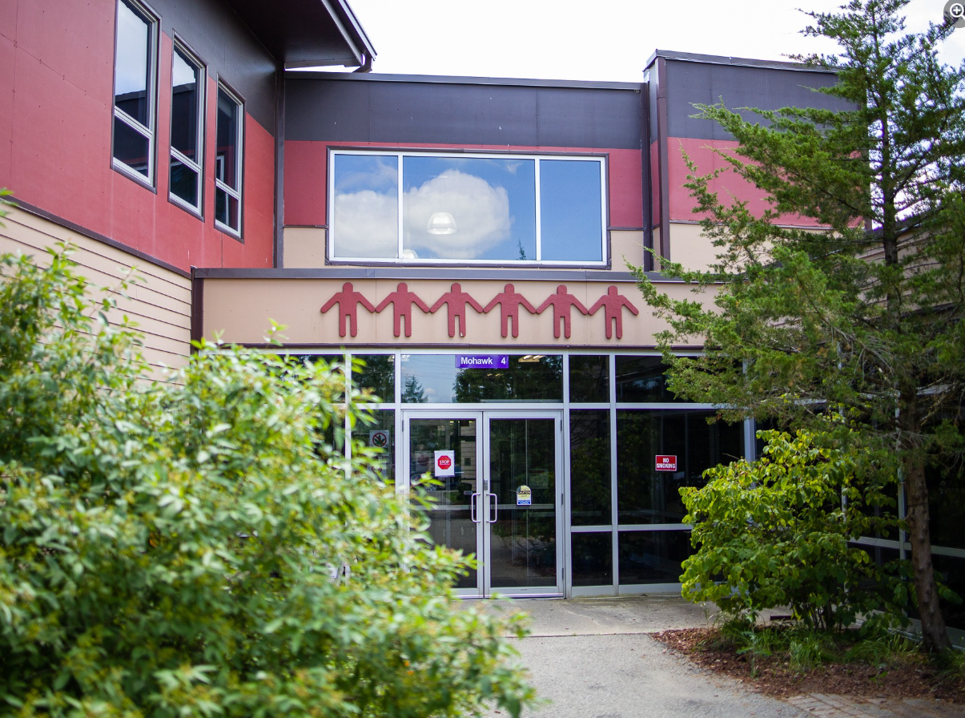
Grand River Employment and Training Inc. (GRETI) is seeking the position of Executive Administrative Assistant who will coordinate and assist the CEO to ensure that GRETI makes consistent and timely progress on achieving organizational goals and objectives.
Executive Administrative Assistant
One (1) Full Time Position Available

The Executive Administrative Assistant shall possess the following skills: Problem Solving, Communication, Networking & Relationship Building, Planning and Organization. In addition to these skills, you must possess the following qualifications:
Qualifications:
- Diploma in Business Administration, or related discipline
- Three (3) to five (5) years of work-related experience in a senior administrative role
If you have desire to anticipate and proactively provide assistance in managing the needs of GRETI, tell us who you are by submitting the following:
- Cover letter stating how you meet the demands of this position
- Up to Date Resume highlighting your qualifications, and
- Three (3) work related references (letters not required)
Please submit a covering letter and resume that demonstrates how you meet the requirements, GRETI cannot make assumptions about your education and experience. We thank all those who apply.
GRETI offers a competitive wage, group benefits and pension for full time employees, three (3) weeks’ vacation to start, along with other non-required benefits
Applications must be submitted to: Human Resources, P.O. Box 69, 16 Sunrise Court, Ohsweken, Ontario N0A 1M0
Applications may also be faxed and emailed to (Fax) (519) 445-4777 or kristen@gretisn.org until 4:00 PM on Friday November 7, 2025.
GRETI is committed to providing an inclusive and barrier-free work environment, starting with the hiring process. If you are contacted by GRETI regarding a job opportunity, please advise if you have any restrictions that need to be accommodated. All information received in relation to accommodation will be kept confidential. Based on the need to provide professional services, only those applicants meeting the minimum qualifications will be contacted for an interview.

Job Title: | Executive Administrative Assistant
Location: | Grand River Employment & Training Inc. (GRETI)
Reports To: | CEO, GRETI, INC.

A. PURPOSE:
The Executive Administrative Assistant is responsible for a wide variety of executive duties in support of the CEO and the Board of Directors. The Executive Administrative Assistant will coordinate and assist the CEO to ensure that GRETI makes consistent and timely progress on achieving organizational goals and objectives.

The Executive Administrative Assistant is responsible for assisting the department and organization in reaching their goals and objectives by continuously enhancing operations through more efficient and effective work processes while maintaining the level of professionalism expected by GRETI (as outlined in the Policies and Procedures Manuals) and upholding the ethics of the position.
B. CORE COMPETENCIES:
- Accountability  - Problem Solving  - Communication  - Networking & Relationship Building | - Planning and Organizing  - Research and Analysis  - Critical Thinking  - Ethics and Integrity
C. QUALIFICATIONS:
  - Diploma in Business Administration, or related discipline
  - Three (3) to five (5) years of work-related experience in a senior administrative role

Knowledge
- Strong knowledge of office procedures and practices
- Knowledgeable of & experience working with various levels of government & contribution agreements
- Knowledgeable of & experience in strategic planning & execution
- Knowledge of contracting, negotiating, and change management

Skills
- Ability to respond appropriately in pressure situations
- Able to effectively communicate both verbally and in writing
- Strong presentation skills
- Able to build and maintain relationships with other departments, key business partners & government agencies
- Strong problem identification & problem resolution skills

FOR A COMPLETE COPY OF THE JOB DESCRIPTION, PLEASE CONTACT HUMAN RESOURCES at kristen@gretisn.org, please allow 24 hours for a return
e-mail or call (519) 445-2222 ext. 3113.

