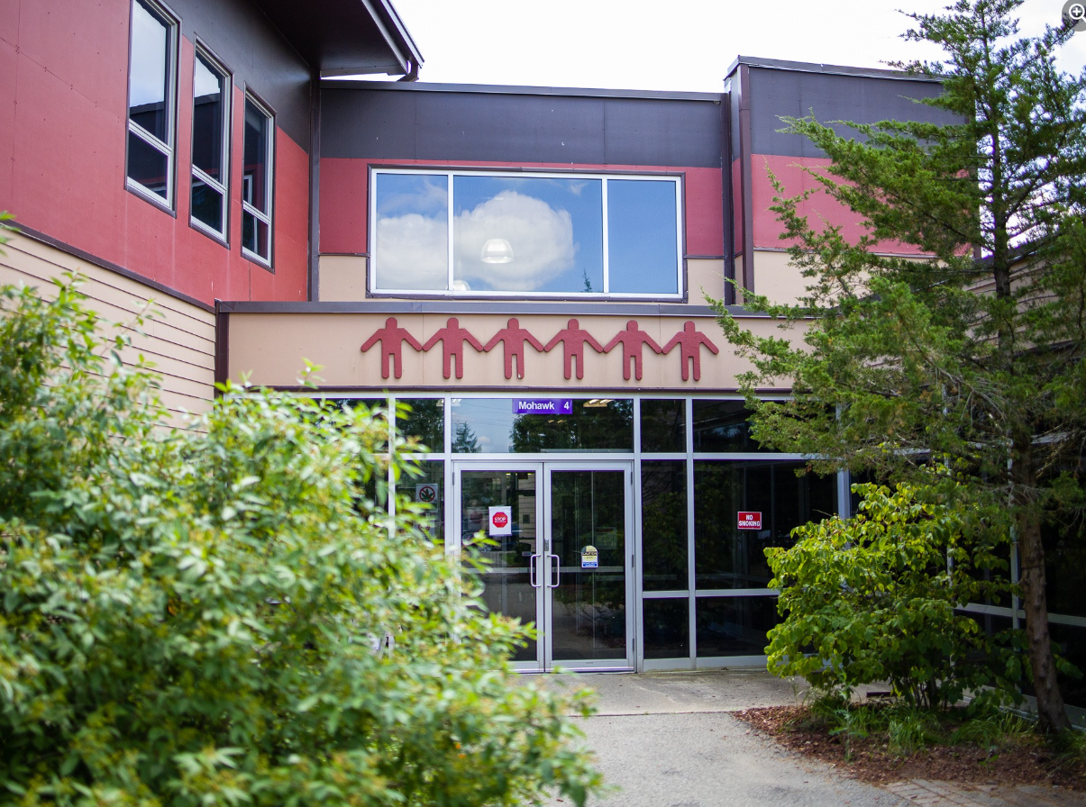
Grand River Employment and Training Inc. (GRETI) is seeking a highly enthusiastic, hands-on, and relational individual who is responsible for ensuring the coordinated and effective delivery of comprehensive services and support for students within OSTTC.
OSTTC Student Services Team Lead
One (1) Full Time Position Available
The Student Services Team Lead shall possess the following skills: Student Service Orientated, Research and Analysis, Collaboration, Problem Solving. In addition to these skills, you must possess the following qualifications:
Qualifications:
- Diploma/Degree in Education, Public Policy, Business Administration, or related discipline
- Three (3) to five (5) years of experience planning, organizing & leading programs designed to support student engagement, or training & development programming
If you have desire to foster a positive, supportive, and inclusive environment that promotes student success, well-being, and academic progression, tell us who you are by submitting the following:
- Cover letter stating how you meet the demands of this position
- Up to Date Resume highlighting your qualifications, and
- Three (3) work related references (letters not required)
Please submit a covering letter and resume that demonstrates how you meet the requirements, GRETI cannot make assumptions about your education and experience. We thank all those who apply.
GRETI offers a competitive wage, group benefits and pension for full time employees, three (3) weeks’ vacation to start, along with other non-required benefits
Applications must be submitted to: Human Resources, P.O. Box 69, 16 Sunrise Court, Ohsweken, Ontario N0A 1M0
Applications may also be faxed and emailed to (Fax) (519) 445-4777 or kristen@gretisn.org until 4:00 PM on Friday February 6, 2026.
GRETI is committed to providing an inclusive and barrier-free work environment, starting with the hiring process. If you are contacted by GRETI regarding a job opportunity, please advise if you have any restrictions that need to be accommodated. All information received in relation to accommodation will be kept confidential. Based on the need to provide professional services, only those applicants meeting the minimum qualifications will be contacted for an interview.
Job Title: | Student Services Team Lead
Location: | Ogwehoweh Skills and Trade Training Centre
Reports To: | OSTTC Operations Manager

A. PURPOSE:
The Student Services Team Lead is responsible for the planning, implementation, and evaluation of student support systems, and collaborating with faculty and staff of Ogwehoweh Skills and Trades Training Centre (OSTTC) to narrow the gap of attrition and improve overall student satisfaction and success.

The Student Services Team Lead continuously strives to improve operations and streamline work processes through efficient and effective service coordination, team commitment and the achievement of organizational goals and objectives while maintaining the level of professionalism expected by GRETI (as outlined in the Policies and Procedures Manuals) and upholding the ethics of the position.
B. CORE COMPETENCIES:
- Student Service Orientated  - Research and Analysis  - Collaboration  - Problem Solving | - Mediation and Conflict Resolution  - Planning & Organization  - Networking & Relationship Building
C. QUALIFICATIONS:
The Student Services Team Lead shall possess Diploma/Degree in Education, Public Policy, Business Administration, or related discipline with a Three (3) to five (5) years of experience planning, organizing & leading programs designed to support student engagement, or training & development programming

Knowledge
- Knowledge of Six Nations culture & community partners
- Understanding of socio-economic barriers for First Nations people
- Experience in development & recruitment
- Strong computer skills including Microsoft Office programs
Skills
- Strong oral & written communications skills
- Strong presentation skills
- Excellent networking skills
- Excellent organization & liaison skills

FOR A COMPLETE COPY OF THE JOB DESCRIPTION, PLEASE CONTACT HUMAN RESOURCES at kristen@gretisn.org, please allow 24 hours for a return
e-mail or call (519) 445-2222 ext. 3113.

