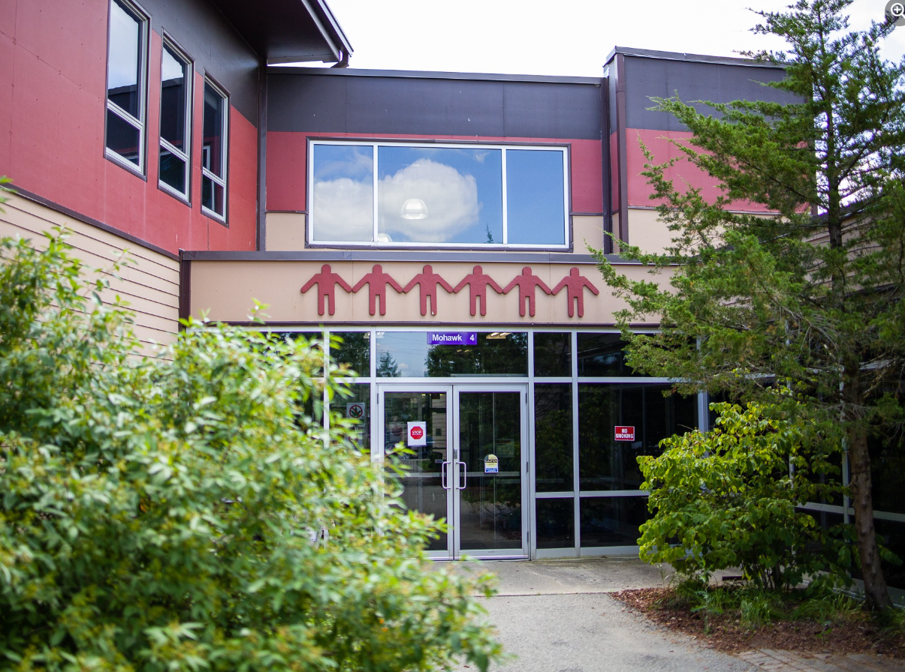
Grand River Employment and Training Inc. (GRETI) is seeking a Cultural Experiences Coordinator to lead and support the delivery of culturally rooted programming and events that share Six Nations knowledge, traditions, and history. This role focuses on creating engaging learning experiences for both community members and visitors while strengthening cultural awareness and participation through well-organized activities and initiatives.
Cultural Experiences Coordinator
One (1) Full Time Position Available
Salary Range: $45,700 - $59,500

The Cultural Experiences Coordinator shall possess the following skills: Dependability, Communication, Critical Thinking. In addition to these skills, you must possess the following qualifications:
Qualifications:
- Diploma in Environmental Technology, Tourism & Hospitality or a related discipline
- One (1) to three (3) years of experience in tourism, hospitality, finance or administration
If you have desire to promote, share, and preserve Six Nations culture through meaningful programming and community engagement., tell us who you are by submitting the following:
- Cover letter stating how you meet the demands of this position
- Up to Date Resume highlighting your qualifications, and
- Three (3) work related references (letters not required)
Please submit a covering letter and resume that demonstrates how you meet the requirements, GRETI cannot make assumptions about your education and experience. We thank all those who apply.
GRETI offers a competitive wage, group benefits and pension for full time employees, three (3) weeks’ vacation to start, along with other non-required benefits
Applications must be submitted to: Human Resources, P.O. Box 69, 16 Sunrise Court, Ohsweken, Ontario N0A 1M0
Applications may also be faxed and emailed to (Fax) (519) 445-4777 or kristen@gretisn.org until 4:00 PM on Friday May 8, 2026.
GRETI is committed to providing an inclusive and barrier-free work environment, starting with the hiring process. If you are contacted by GRETI regarding a job opportunity, please advise if you have any restrictions that need to be accommodated. All information received in relation to accommodation will be kept confidential. Based on the need to provide professional services, only those applicants meeting the minimum qualifications will be contacted for an interview.
Job Title: | Cultural Experiences Coordinator
Location: | Grand River Employment & Training Inc. (GRETI)
Reports To: | Communications Team Lead

A. PURPOSE:
The Cultural Experiences Coordinator is responsible for the development and delivery of cultural programs, workshops, and activities. This includes planning and facilitating workshops, summer camps, and events; managing budgets; supporting marketing and promotions; coordinating appointments and schedules; providing client and project consultation; and attending or organizing meetings and events.

This role promotes and upholds the values of good minds and thoughts, consideration for future generations, respect, responsibility, creativity, and lifelong learning, reflecting the culture and philosophy of the Nation.

Tourism activities will offer visitors to Six Nations a meaningful cultural experience through interpretive programming that enhances understanding and appreciation of Six Nations’ natural resources, society, history, and culture.

The Cultural Experiences Coordinator is responsible for assisting the department and organization in reaching their goals and objectives by continuously enhancing operations through more efficient and effective work processes while maintaining the level of professionalism expected by GRETI (as outlined in the Policies and Procedures Manuals) and upholding the ethics of the position.

B. CORE COMPETENCIES:
- Dependability  - Communication  - Critical Thinking  - Confidentiality | - Dependability  - Communication  - Critical Thinking  - Confidentiality
C. QUALIFICATIONS:
The Cultural Experiences Coordinator shall possess Diploma in Environmental Technology, Tourism & Hospitality or a related disciple with a One (1) to three (3) years of experience in tourism, hospitality, finance or administration

Knowledge
- Research techniques, components to program development, marketing, & partnership development are assets.
- Knowledge of Six Nations community & it’s social, economic, tourism & cultural assets
- A strong desire to preserve & restore the natural environment & the cultural heritage of the Six Nations of the Grand River Territory
- Willingness to participate in administration of eco-tourism & cultural awareness activities
Skills
- Skills in organizing, prioritizing, problem solving & analyzing
- Good interpersonal communication skills & ability to effectively work with management, clients, co-workers & the public
- Working as part of a multi-disciplinary team
- Ability to work independently with minimum supervision when necessary
- Ability to work evenings & weekends

FOR A COMPLETE COPY OF THE JOB DESCRIPTION, PLEASE CONTACT HUMAN RESOURCES at kristen@gretisn.org, please allow 24 hours for a return
e-mail or call (519) 445-2222 ext. 3113.
We use artificial intelligence tools to support the screening, assessment, and selection of applicants in our GRETI hiring process. These tools assist our team and do not replace human decision-making.

