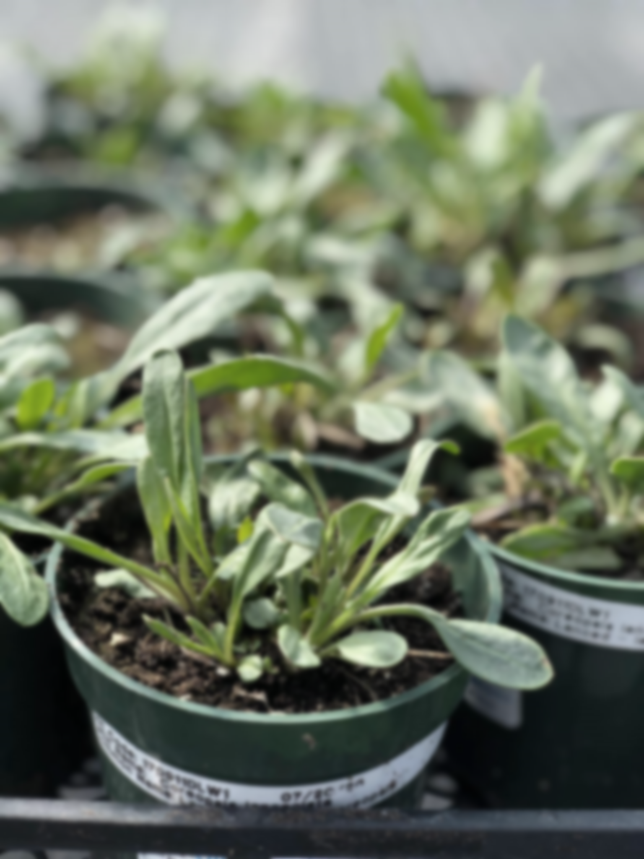
Grand River Employment and Training Inc. (GRETI) is seeking a Greenhouse Worker to support daily operations in plant production and care. This role involves watering, planting, weeding, and maintaining healthy growing conditions, as well as assisting with pest control and general greenhouse upkeep. The Greenhouse Worker will contribute to producing high-quality plants while supporting team and organizational goals.
Greenhouse Worker TOJ
Two (2) Seasonal Fixed Term Positions Available
Salary Range: $32,760 - $43,400

The Job Title shall possess the following skills: Dependability, teamwork, communication. In addition to these skills, you must possess the following qualifications:
Qualifications:
- High School Diploma or GED Diploma
- Up to one (1) year of experience in horticulture, nursery production or native plants, an asset

If you have desire to preserve & restore the natural environment and work in a hands-on greenhouse environment, tell us who you are by submitting the following:
- Cover letter stating how you meet the demands of this position
- Up to Date Resume highlighting your qualifications, and
- Three (3) work related references (letters not required)
Kayanase’s Mission: is to restore the health and beauty of Mother Earth, using science-based approaches and Traditional Ecological Knowledge (TEK).

Please submit a covering letter and resume that demonstrates how you meet the requirements, GRETI cannot make assumptions about your education and experience. We thank all those who apply. Only those selected for further consideration will be contacted
Applications may be submitted to: Human Resources, P.O Box 69, Sunrise Court, Ohsweken, Ontario N0A 1M0
Applications may also be faxed and emailed to (Fax) (519) 445-4777 or kristen@gretisn.org until 4:00 PM on April 24, 2026. Late applications will not be considered.
GRETI is committed to providing an inclusive and barrier-free work environment, starting with the hiring process. If you are contacted by GRETI regarding a job opportunity, please advise if you have any restrictions that need to be accommodated. All information received in relation to accommodation will be kept confidential. Due to the special program of Training on the Job (TOJ) eligibility criteria, preference will be given to Six Nations band members to provide services for the Six Nations community; based on the need to provide professional services, only those applicants meeting the minimum qualifications will be contacted for an interview.
Job Title: | Greenhouse Worker TOJ
Location: | Kayanase Greenhouse
Reports To: | Plant Production Team Lead

A. PURPOSE:
The Greenhouse Worker is responsible for being part of a growing team focused on plant care at Kayanase’s native plant nursery, including watering, weeding, planting, fertilizing, and pest control, while also assisting with customer service and inventory management.

The Greenhouse Worker is responsible for assisting the department and organization in reaching their goals and objectives by continuously enhancing operations through more efficient and effective work processes while maintaining the level of professionalism expected by GRETI (as outlined in the Policies and Procedures Manuals) and upholding the ethics of the position.

B. CORE COMPETENCIES:
- Dependability  - Teamwork  - Communication | - Problem Solving  - Planning & organizing

C. QUALIFICATIONS:
The Greenhouse Worker shall possess High School Diploma or GED Diploma with a Up to one (1) year of experience in horticulture, nursery production or native plants, an asset.
Abilities
- Ability to work in all kinds of weather
- Ability to collect data in an organized & detail specific manner
- Ability to take direction, follow instruction & be a team player
- Ability to work independently with minimum supervision
Skills
- Physically fit & hardworking, able to lift minimum of 50 lbs.
- Excellent interpersonal & communication skills
- Willingness to work flexible hours including some evenings

FOR A COMPLETE COPY OF THE JOB DESCRIPTION, PLEASE CONTACT HUMAN RESOURCES at kristen@gretisn.org, please allow 24 hours for a return
e-mail or call (519) 445-2222 ext. 3113.
We use artificial intelligence tools to support the screening, assessment, and selection of applicants in our GRETI hiring process. These tools assist our team and do not replace human decision-making.

