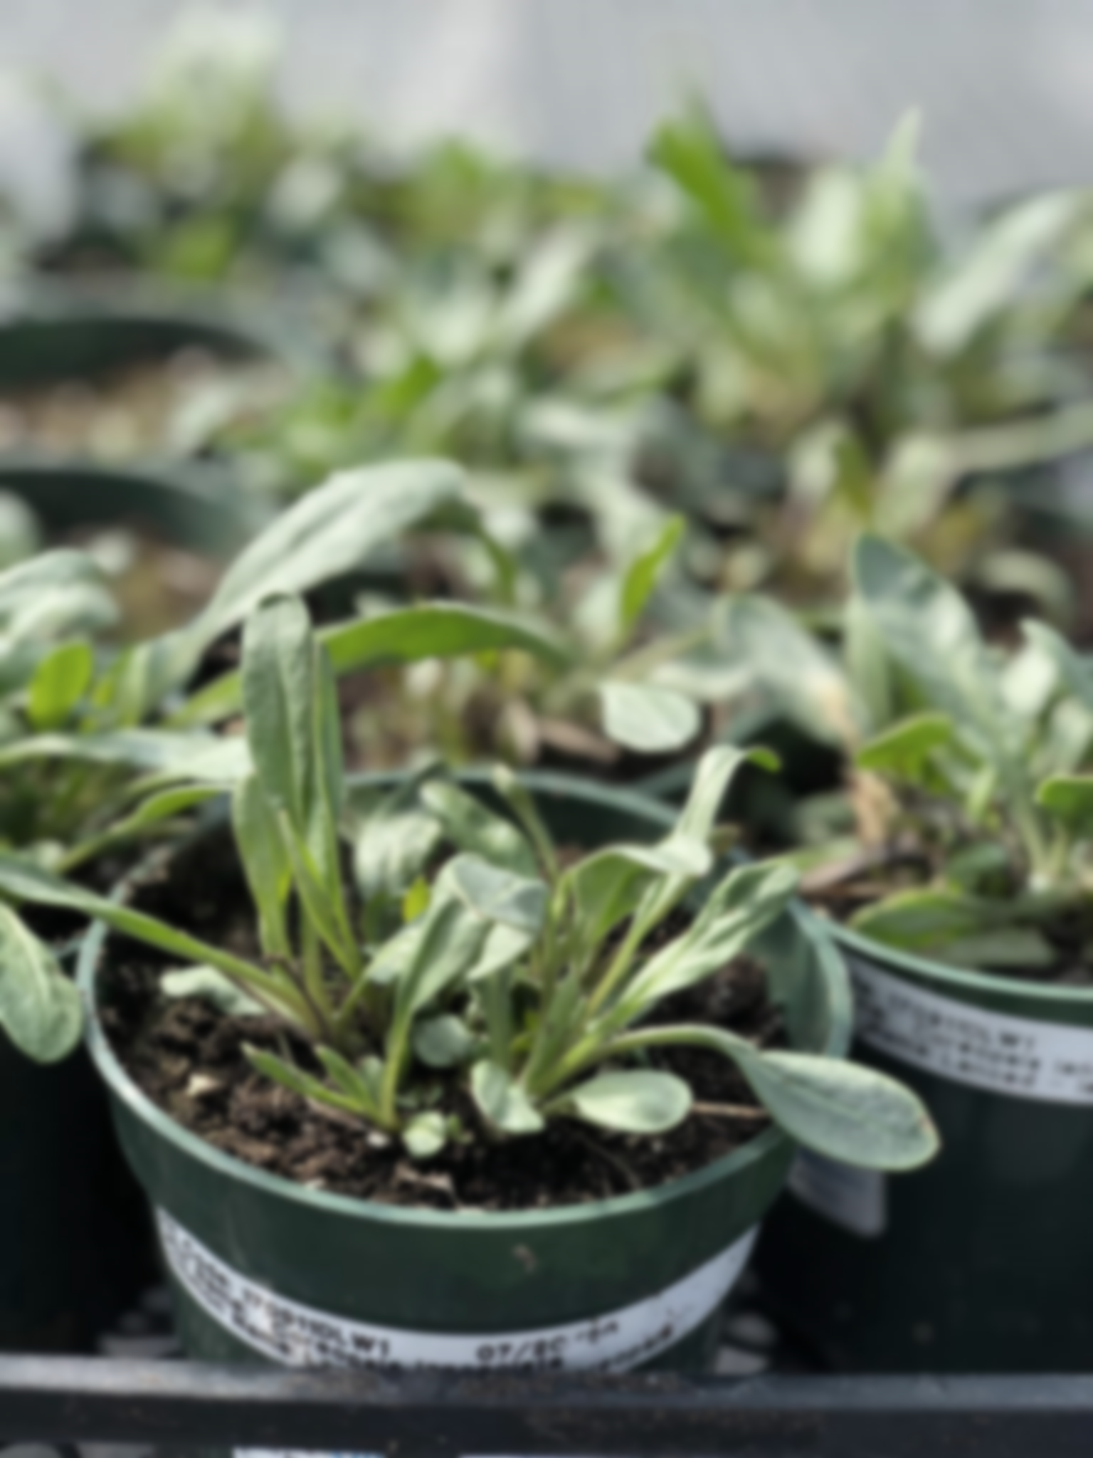**Grand River Employment and Training Inc. (GRETI) is seeking a dedicated individual to join a growing team focused on native seed production in support of Kayanase’s nursery and ecological restoration efforts. As the Seed Production Assistant, you will help scout, identify, and collect seeds from cultivated plants, and assist with the development and care of native plant seed orchards.**

**Seed Production Assistant TOJ  
One (1) Fixed Term Position Available**

**As the Plant Production Assistant, you should bring a strong work ethic, a passion for preserving the natural environment, and the ability to work in all weather conditions. Strong communication and problem-solving skills are essential, along with the following qualifications:**

**Qualifications:**

* **Minimum Grade 10 with a willingness to actively learn**
* **Experience in horticulture, nursery production or native plants is an asset**
* **Physically fit & hardworking, able to lift minimum of 50 lbs.**

**If you have a strong desire to help the native environment thrive, tell us who you are by submitting the following:**

1. **Cover letter stating how you meet the demands of this position**
   1. **As a requirement for training on the job (TOJ) funding eligibility please include Six Nations Band Number on the cover letter**
2. **Up to Date Resume highlighting your qualifications, and**
3. **Three (3) work-related references (letters not required)**

**Kayanase’s Mission: is to restore the health and beauty of Mother Earth, using science-based approaches and Traditional Ecological Knowledge (TEK).**

***Please submit a covering letter and resume that demonstrates how you meet the requirements, GRETI cannot make assumptions about your education and experience. We thank all those who apply. Only those selected for further consideration will be contacted***

Applications may be submitted to: Human Resources, P.O Box 69, Sunrise Court, Ohsweken, Ontario N0A 1M0

Applications may also be faxed and emailed to [**kristen@gretisn.org**](mailto:kristen@gretisn.org) or **Fax (519) 445-4777** or until **4:00 P.M** on **May 16, 2024**. Late applications will not be considered.

*GRETI is committed to providing an inclusive and barrier-free work environment, starting with the hiring process. If you are contacted by GRETI regarding a job opportunity, please advise if you have any restrictions that need to be accommodated. All information received in relation to accommodation will be kept confidential.* ***Due to the special program of Training on the Job (TOJ) eligibility criteria, preference will be given to Six Nations band members to provide services for the Six Nations community;*** *based on the need to provide professional services, only those applicants meeting the minimum qualifications will be contacted for an interview.*

|  |  |
| --- | --- |
| **Job Title:** | **Seed Production Assistant** |
| **Location:** | **Kayanase Greenhouse** |
| **Reports To:** | **Kayanase Operations Manager** |

**A. PURPOSE:**

The **Seed Production** **Assistant** is responsible for working as an important part of a growing team focused on native seed production in support of Kayanase’s nursery and ecological restoration initiatives. Your job will involve scouting, identifying, and collecting seeds from wild or cultivated plants, ensure proper storage and processing, assisting with the development and maintenance of native seed orchards at Kayanase, and potentially assisting with quality control and data management.

**B. CORE COMPETENCIES:**

|  |  |
| --- | --- |
| * Dependability * Native plant & seed knowledge * Teamwork | * Problem Solving * Safety Procedures * Communication Skills |

**C. QUALIFICATIONS:**

The Plant Production Assistant shall posses a minimum Grade 10 with a willingness to actively learn. Experience in horticulture, nursery production or native plants is an asset. The Plant Production Assistant shall be physically fit and hardworking, able to lift minimum of 50 lbs.

**Skills**

* Strong desire to preserve & restore the natural environment
* Ability to work independently with minimum supervision

**Knowledge**

* Ability to work in all kinds of weather
* Ability to learn fast and focus on attention to detail
* Ability to take direction and be a team player

**FOR A COMPLETE COPY OF THE JOB DESCRIPTION, PLEASE CONTACT HUMAN RESOURCES at** [**kristen@gretisn.org**](mailto:kristen@gretisn.org)**, please allow 24 hours for a return e-mail or call (519) 445-2222 ext. 3113.**