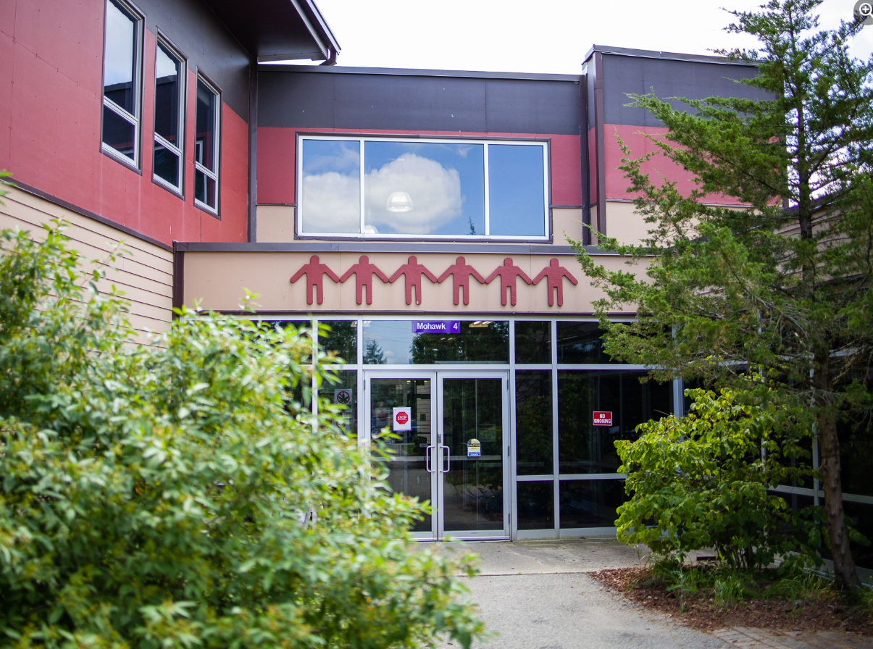**Grand River Employment and Training Inc. (GRETI) is seeking a collaborative and results driven leader to join our team as a Programs & Services Team Lead. This role is responsible for managing a team of Employment and Training Coaches, the Student Office Coordinator, and the GREAT Mentor to ensure the delivery of high-quality client services.**

**Programs & Services Team Lead   
One (1) Full Time Position Available**

**The Programs & Services Team Lead shall possess the following skills: creative & analytical thinking, mediation & negotiation as well as results oriented. In addition to these skills, you must possess the following qualifications:**

**Qualifications:**

* **Diploma/Degree in Social Work, Business Administration, or relevant Humanities field**
* **Minimum of three (3) to five (5) years’ experience in counselling**

**If you have desire to help our community members thrive through employment and training, tell us who you are by submitting the following:**

1. **Cover letter stating how you meet the demands of this position**
2. **Up to Date Resume highlighting your qualifications, and**
3. **Three (3) work related references (letters not required)**

**Please submit a covering letter and resume that demonstrates how you meet the requirements, GRETI cannot make assumptions about your education and experience. We thank all those who apply.**

***GRETI offers a competitive wage, group benefits and pension for full time employees, three (3) weeks’ vacation to start, along with other non-required benefits***

**Applications must be submitted to: Human Resources, P.O. Box 69, 16 Sunrise Court, Ohsweken, Ontario N0A 1M0**

Applications may also be faxed and emailed to **(Fax) (519) 445-4777** or [**kristen@gretisn.org**](mailto:kristen@gretisn.org) until **4:00 PM** on **August 29, 2025**.

*GRETI is committed to providing an inclusive and barrier-free work environment, starting with the hiring process. If you are contacted by GRETI regarding a job opportunity, please advise if you have any restrictions that need to be accommodated. All information received in relation to accommodation will be kept confidential. Based on the need to provide professional services, only those applicants meeting the minimum qualifications will be contacted for an interview.*

|  |  |
| --- | --- |
| **Job Title:** | Programs & Services Team Lead |
| **Location:** | Grand River Employment & Training (GREAT) |
| **Reports To:** | GREAT Operations Managers |

**A. PURPOSE:**

The **Programs & Services Team Lead** is responsible for the management of Employment and Training Coaches individually and as a collective for the purpose of achieving strategic objectives as they relate to client services. This involves coordinating, organizing, and evaluating the team’s activities and making changes that will improve outcomes. The Programs & Services Team Lead shares in the responsibility of filling in for team members as required. The Programs & Services Team Lead is also responsible for the management of the Student Office Coordinator and the GREAT mentor.

**B. CORE COMPETENCIES:**

|  |  |
| --- | --- |
| * Accountability * Results Oriented * Planning & Organizing * Creative & Analytical Thinking | * Critical Thinking * Problem Solving * Mediation & Negotiation * Resource& Fiscal Management |

**C. QUALIFICATIONS:**

The Programs & Services Team Lead shall possess a Diploma/Degree in Social Work, Business Administration, or relevant Humanities field with a minimum of three (3) to five (5) years’ experience in counselling.

**Knowledge**

* Knowledge of computers and various software programs
* Understanding of societal issues and barriers to employment
* Demonstrated capabilities including strategic planning, service analysis and managing client caseloads for team members
* Clear understanding of daily operational requirements as it relates to quality customer service standards

**Skills**

* Self-directed and able to work with limited supervision
* Ability to motivate team members to achieve high levels of performance
* Excellent interpersonal and oral and written communication skills
* Demonstrated ability to make decisions and resolve conflicts

**FOR A COMPLETE COPY OF THE JOB DESCRIPTION, PLEASE CONTACT HUMAN RESOURCES at** [**kristen@gretisn.org**](mailto:kristen@gretisn.org)**, please allow 24 hours for a return   
e-mail or call (519) 445-2222 ext. 3113.**