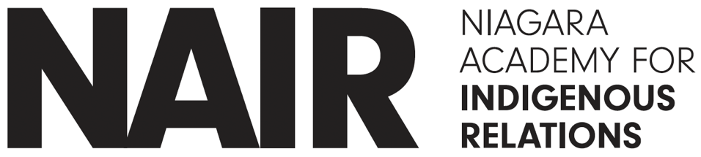

Job Title: General Manager
Organization: Niagara Academy for Indigenous Relations (NAIR)
Reports To: Board of Directors
Employment Type: Full-Time
Location: Six Nations of the Grand River | Niagara Region (with travel as required)

Position Summary

The General Manager (GM) is responsible for the coordination and operational management of the Niagara Academy for Indigenous Relations, a not-for-profit organization dedicated to advancing Indigenous education, cultural awareness, relations initiatives, environmental advocacy, and community engagement.

Working under the direction of the Board of Directors, the GM ensures the successful planning, delivery, and evaluation of programs and projects while maintaining alignment with the organization’s mission, values, and strategic priorities.

Given the nature of the organization’s work and its commitment to Indigenous leadership and self-determination, qualified Indigenous candidates are encouraged to apply.

Key Responsibilities

1. Organizational Leadership & Governance
• Implement the strategic direction set by the Board of Directors.
• Provide regular updates, reports, and recommendations to the Board on organizational performance, risks, and opportunities.
• Support Board processes, including meeting coordination, reporting, and policy implementation.
• Ensure compliance with all legal, regulatory, and ethical standards applicable to not-for-profit organizations within Ontario.
• Uphold and promote Indigenous values, protocols, and culturally appropriate practices across all operations.

2. Program & Project Management
• Plan, develop, and oversee programs and initiatives, including educational workshops, cultural events, training programs, publications, films, tours, conferences, and community outreach activities.
• Coordinate project timelines, deliverables, and resource allocation.
• Monitor and evaluate program effectiveness, ensuring alignment with community needs and organizational goals.
• Foster collaboration with Indigenous communities, Elders, Knowledge Holders, and partner organizations.
• Ensure culturally respectful and inclusive program delivery.

3. Financial Management & Fundraising
• With the Board of Directors develop and manage the annual budget.
• Oversee financial operations, including accounting, reporting, and audits.
• Ensure responsible stewardship of organizational funds and resources.
• Identify and pursue funding opportunities, including grants, sponsorships, and partnerships.
• Support fundraising initiatives and maintain relationships with donors and funding agencies.

4. Human Resources & Team Leadership
• Recruit, supervise, and support staff, contractors, and volunteers.
• Foster a positive, inclusive, and culturally safe workplace environment.
• Develop and implement HR policies and procedures.
• Conduct performance evaluations and provide ongoing professional development opportunities.
• Promote team collaboration and accountability.

5. Community Engagement & Partnerships
• Build and maintain strong relationships with Indigenous communities, organizations, allies, educational institutions, and government agencies.
• Act as a key representative and ambassador for the organization.
• Support reconciliation efforts through meaningful partnerships and engagement strategies.
• Ensure the voices of the organization’s Associates are reflected in programming and decision-making.

6. Communications & Public Relations
• Oversee the development and execution of communication strategies.
• Ensure consistent and culturally appropriate messaging across all platforms.
• Working with the Board of Directors engage in public relations, media engagement, and stakeholder communications.
• Promote awareness of the organization’s mission, programs, and impact.

7. Operational Management
• Oversee day-to-day operations of the organization.
• Develop and maintain operational policies, procedures, and systems.
• Ensure effective use of organizational resources, including facilities, technology, and equipment.
• Manage risk and implement appropriate mitigation strategies.

8. Monitoring, Evaluation & Reporting
• Establish metrics to measure organizational and program success.
• Prepare regular reports for the Board, funders, and stakeholders.
• Ensure transparency and accountability in all reporting processes.
• Use data and feedback to inform continuous improvement.

Qualifications & Experience

• Minimum 3 to 5 years of leadership experience, preferably in a not-for-profit Indigenous organization.
• Demonstrated experience working with Indigenous communities, organizations, and cultural frameworks.
• Strong knowledge of Indigenous relations and cultural competency.
• Proven experience in program management, fundraising, and financial oversight.
• Excellent leadership, communication, and interpersonal skills.
• Experience working with a Board of Directors is an asset.

Core Competencies

• Deep understanding of Indigenous worldviews, traditions, and protocols
• Commitment to Indigenous self-determination and collegial approaches
• Strategic thinking and decision-making
• Relationship building and collaboration
• Financial and operational management
• Problem-solving and adaptability
• Integrity, decency, accountability, and transparency

Working Conditions

• Occasional evening and weekend work required.
• Travel within the Niagara Region and surrounding areas may be necessary.
• Engagement in community events and ceremonies.

Commitment to Equity

The Niagara Academy for Indigenous Relations is committed to equity, diversity, and inclusion while advancing Indigenous relations.

Salary

$70,000 (plus professional development training and travel)

Probation Period

Four months

How to Apply

Interested candidates are invited to submit a resume and cover letter outlining their qualifications and connection to the organization’s mission, by email to:

Niagara Academy for Indigenous Relations
P.O. Box 187
Six Nations of the Grand River
Ohsweken, ON N0A 1M0
niagaraacademy.org
niagaraacademy1764@gmail.com

Deadline for Applications

COB, May 22, 2026

