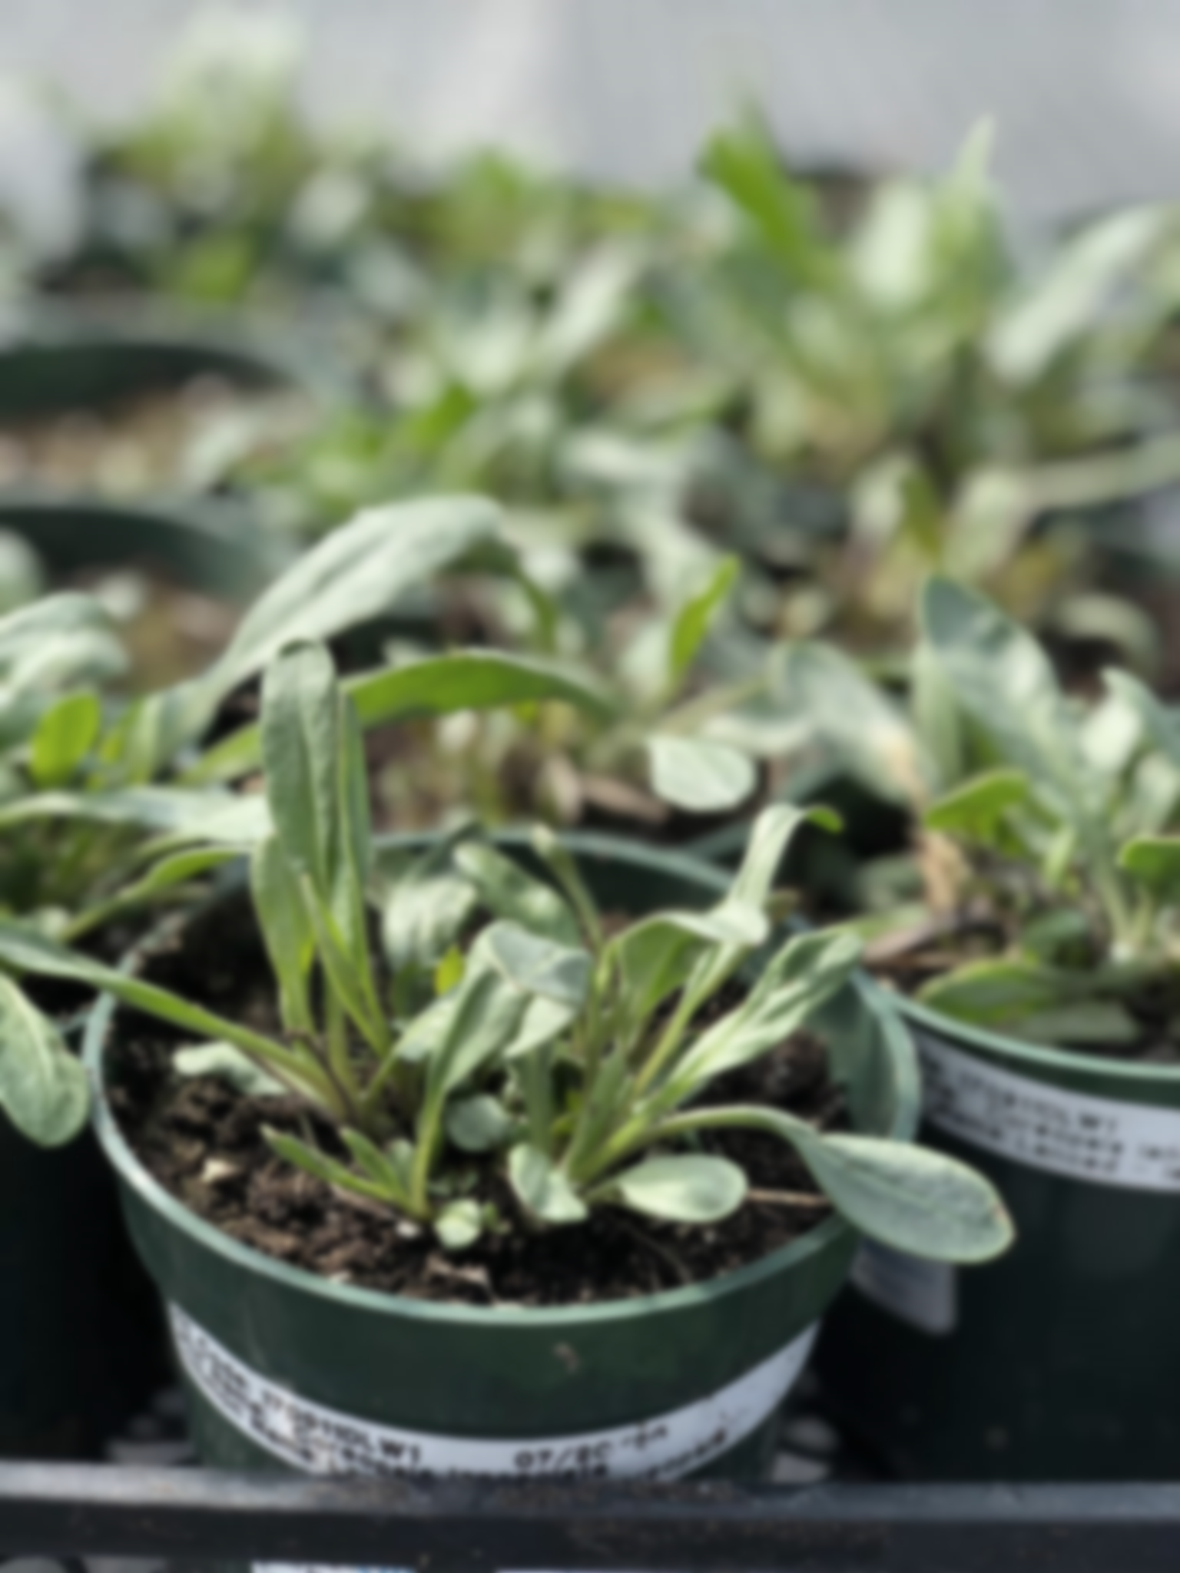**Grand River Employment and Training Inc. (GRETI) is seeking a dedicated, team oriented individual who is passionate about restoring the health and beauty of Mother Earth. As the Restoration Worker you will be responsible for working with the Ecological Team, and assist with restoration projects off site.**

**Restoration Worker TOJ  
One (1) Fixed Term Position Available**

**As the Restoration Worker you shall possess the following skills; excellent physical strength & endurance, dependability, teamwork and problem solving abilities. In addition to these skills, you must possess the following qualifications:**

**Qualifications:**

* **Minimum Grade 10 with a willingness to actively learn**
* **Experience in landscaping, horticulture, plant identification &/or tree planting is an asset**
* **Excellent physical strength & endurance, able to lift minimum of 50 lbs.**

**If you have a strong desire to help the native environment thrive, tell us who you are by submitting the following:**

1. **Cover letter stating how you meet the demands of this position**
   1. **As a requirement for training on the job (TOJ) funding eligibility please include Six Nations Band Number on the cover letter**
2. **Up to Date Resume highlighting your qualifications, and**
3. **Three (3) work-related references (letters not required)**

**Kayanase’s Mission: is to restore the health and beauty of Mother Earth, using science-based approaches and Traditional Ecological Knowledge (TEK).**

***Please submit a covering letter and resume that demonstrates how you meet the requirements, GRETI cannot make assumptions about your education and experience. We thank all those who apply. Only those selected for further consideration will be contacted***

Applications may be submitted to: Human Resources, P.O Box 69, Sunrise Court, Ohsweken, Ontario N0A 1M0

Applications may also be faxed and emailed to [**kristen@gretisn.org**](mailto:kristen@gretisn.org) or **Fax (519) 445-4777** or until **4:00 P.M** on **May 16, 2024**. Late applications will not be considered.

*GRETI is committed to providing an inclusive and barrier-free work environment, starting with the hiring process. If you are contacted by GRETI regarding a job opportunity, please advise if you have any restrictions that need to be accommodated. All information received in relation to accommodation will be kept confidential.* ***Due to the special program of Training on the Job (TOJ) eligibility criteria, preference will be given to Six Nations band members to provide services for the Six Nations community;*** *based on the need to provide professional services, only those applicants meeting the minimum qualifications will be contacted for an interview.*

|  |  |
| --- | --- |
| **Job Title:** | **Restoration Worker** |
| **Location:** | **Kayanase Greenhouse** |
| **Reports To:** | **Ecological Team Lead** |

**A. PURPOSE:**

The **Restoration Worker** is responsible for being part of an important growing team focused on carrying out ecological restoration, invasive species management, native plant gardening and landscaping projects.

The Restoration Worker continuously strives to improve operations and streamline work processes through efficient and effective service coordination, team commitment and the achievement of organizational goals and objectives while maintaining the level of professionalism expected by GRETI (as outlined in the Policies and Procedures Manuals) and upholding the ethics of the position.

**B. CORE COMPETENCIES**:

|  |  |
| --- | --- |
| * Dependability * Teamwork * Operating Equipment | * Problem Solving * Safety Procedures |

**C. QUALIFICATIONS:**

The Restoration Worker shall posses a minimum Grade 10 with a willingness to actively learn. Experience in landscaping, horticulture, plant identification and or tree planting is an asset. The Restoration worker shall have excellent physical strength and endurance, able to lift minimum of 50 lbs.

**Knowledge**

* Strong desire to preserve & restore the natural environment
* Ability to work independently with minimum supervision

**Skills**

* Ability to work in all kinds of weather & adverse environmental conditions
* Ability to learn fast and focus on attention to detail
* Ability to take direction and be a team player

**FOR A COMPLETE COPY OF THE JOB DESCRIPTION, PLEASE CONTACT HUMAN RESOURCES at** [**kristen@gretisn.org**](mailto:kristen@gretisn.org)**, please allow 24 hours for a return e-mail or call (519) 445-2222 ext. 3113.**