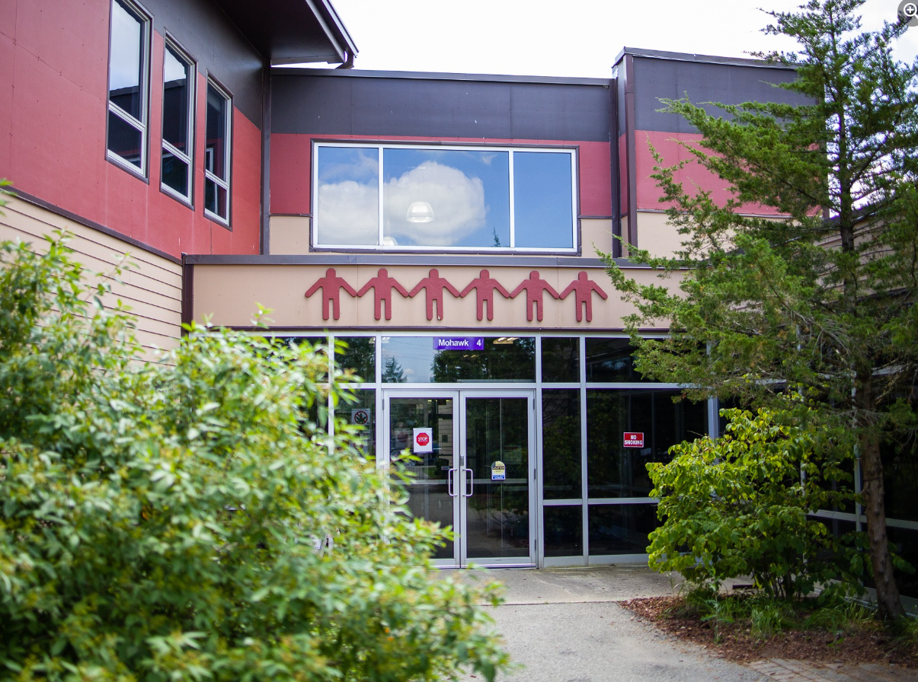
Grand River Employment and Training Inc. (GRETI) is seeking an OSTTC, Dean of Education to lead the Ogwehoweh Skills and Trades Training Centre’s academic and operational initiatives. This role ensures excellence in training programs, drives educational innovation, and fosters key partnerships to support the Centre’s growth and impact
OSTTC, Dean of Education
One (1) Full Time Position Available
Salary Range: $85,700-120,000

The OSTTC, Dean of Education shall possess the following skills: Resource & Fiscal Management, Creative & Analytical Thinking, Leadership & Staff Management. In addition to these skills, you must possess the following qualifications:
Qualifications:
- Degree/Diploma in Business Administration, Public Administration & Governance or related administrative services field
- Five (5) to ten (10) years of work experience in a program management position, post secondary education, trades curriculum development
If you have desire to lead and mentor a team of educators, promote academic excellence, and drive the strategic growth of the organizations training programs, tell us who you are by submitting the following:
- Cover letter stating how you meet the demands of this position
- Up to Date Resume highlighting your qualifications, and
- Three (3) work related references (letters not required)
Please submit a covering letter and resume that demonstrates how you meet the requirements, GRETI cannot make assumptions about your education and experience. We thank all those who apply.
GRETI offers a competitive wage, group benefits and pension for full time employees, three (3) weeks’ vacation to start, along with other non-required benefits
Applications must be submitted to: Human Resources, P.O. Box 69, 16 Sunrise Court, Ohsweken, Ontario N0A 1M0
Applications may also be faxed and emailed to (Fax) (519) 445-4777 or kristen@gretisn.org open until filled.
GRETI is committed to providing an inclusive and barrier-free work environment, starting with the hiring process. If you are contacted by GRETI regarding a job opportunity, please advise if you have any restrictions that need to be accommodated. All information received in relation to accommodation will be kept confidential. Based on the need to provide professional services, only those applicants meeting the minimum qualifications will be contacted for an interview.
Job Title: | OSTTC, Dean of Education
Location: | Ogwehoweh Skills and Trades Training Centre
Reports To: | Executive Director, GRETI Inc.

A. PURPOSE:
The OSTTC, Dean of Education is responsible for planning, organizing, directing, and evaluating the operations of the Ogwehoweh Skills and Trades Training Centre. The OSTTC, Dean of Education is responsible for steering the strategic direction and leadership for the overall administrative operations which includes staff and service administration. This role effectively and efficiently manages the development and direction of the entity to drive the growth of revenue, technical productivity and promote high quality training programs and customer satisfaction. The OSTTC, Dean of Education supports the overall vision & direction for the implementation of the internal operations while building relationships and ensuring the integration of strategic plans with company operations. The OSTTC, Dean of Education establishes key long-term relationships with business partners that enhance the organization’s profitability and market position. This role also manages, provide budgets, and monitors government agreements and reporting.
The OSTTC, Dean of Education is a member of GRETI’s management team and continuously strives to improve operations and streamline work processes through efficient and effective service coordination, team commitment and the achievement of organizational goals and objectives while maintaining the level of professionalism expected by GRETI (as outlined in the Policies and Procedures Manuals) and upholding the ethics of the position.
B. CORE COMPETENCIES:
- Accountability  - Resource & Fiscal Management  - Creative & Analytical Thinking  - Results Orientated | - Network & Relationship Building  - Budgeting & Financial Analysis  - Problem Solving  - Leadership & Staff Management
C. QUALIFICATIONS:
The OSTTC, Dean of Education shall possess Degree/Diploma in Business Administration, Public Administration & Governance or related administrative services field with a five (5) to ten (10) years of work experience in a program management position, post secondary education, trades curriculum development
Knowledge
- Demonstrated management capabilities including strategic planning, program evolution, human recourses management, & budget management
- Ability to uphold curriculum standards & benchmarks
- Detailed knowledge of community resources & services, & ability to access these resources
- Knowledge of computers & various software programs
Skills
- Self-directed & able to work with limited supervision
- Demonstrated ability to work in a team internal to the organization & external to the organization
- Ability to motivate staff members to achieve high levels of performance
- Understanding of societal issues & barriers to employment
- Excellent communication & presentation skills; verbal & written

FOR A COMPLETE COPY OF THE JOB DESCRIPTION, PLEASE CONTACT HUMAN RESOURCES at kristen@gretisn.org, please allow 24 hours for a return
e-mail or call (519) 445-2222 ext. 3113.
We use artificial intelligence tools to support the screening, assessment, and selection of applicants in our GRETI hiring process. These tools assist our team and do not replace human decision-making.

