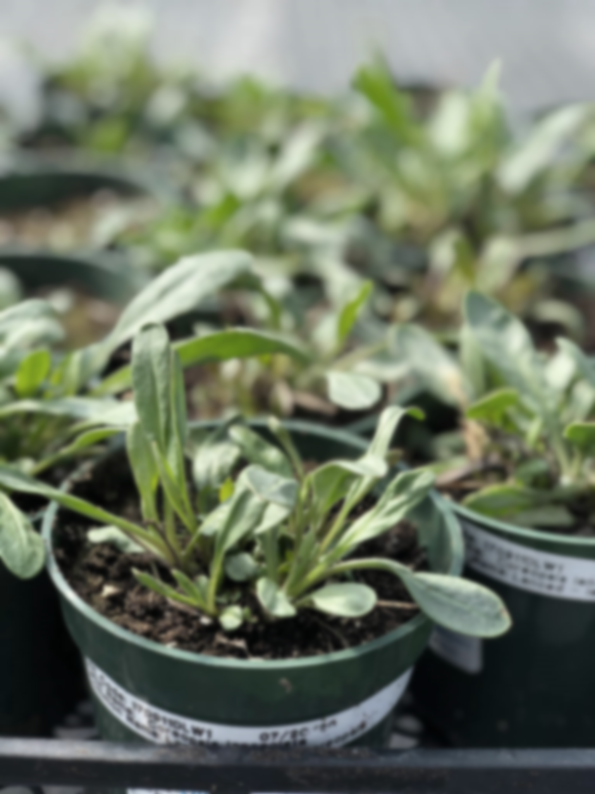**Kayanase is seeking a responsible, reliable individual who has a passion for supporting Kayanase’s mandate of restoring indigenous species. The Greenhouse worker will be responsible for overall greenhouse & nursery production functions along with preparing and assembling plants for orders. If you are interested in working in the greenhouse industry; have strong interpersonal skills, and interest in learning about native plant species, you may be the right fit for this position**

**Greenhouse Worker TOJ  
2 Fixed Term Positions Available**

**Qualifications:**

* **Minimum Grade 10 with a willingness to actively learn**
* **Experience in horticulture, nursery production or native plants, an asset**
* **Physically fit & hardworking, able to life minimum of 50 lbs**

**If you have a strong desire to help the native environment thrive, tell us who you are by submitting the following:**

1. **Cover letter stating how you meet the demands of this position**
   1. **As a requirement for training on the job (TOJ) funding eligibility please include Six Nations Band Number on the cover letter**
2. **Up to Date Resume highlighting your qualifications, and**
3. **Three (3) work-related references (letters not required)**

**Kayanase’s Mission: is to restore the health and beauty of Mother Earth, using science-based approaches and Traditional Ecological Knowledge (TEK).**

***Please submit a covering letter and resume that demonstrates how you meet the requirements, GRETI cannot make assumptions about your education and experience. We thank all those who apply. Only those selected for further consideration will be contacted***

Applications may be submitted to: Human Resources, P.O Box 69, Sunrise Court, Ohsweken, Ontario N0A 1M0

Applications may also be faxed and emailed to [**kristen@gretisn.org**](mailto:kristen@gretisn.org) or **Fax (519) 445-4777** or until **4:00 P.M** on **Friday May 16, 2024**. Late applications will not be considered.

*GRETI is committed to providing an inclusive and barrier-free work environment, starting with the hiring process. If you are contacted by GRETI regarding a job opportunity, please advise if you have any restrictions that need to be accommodated. All information received in relation to accommodation will be kept confidential.* ***Due to the special program of Training on the Job (TOJ) eligibility criteria, preference will be given to Six Nations band members to provide services for the Six Nations community;*** *based on the need to provide professional services, only those applicants meeting the minimum qualifications will be contacted for an interview.*

|  |  |
| --- | --- |
| **Job Title:** | **Greenhouse Worker** |
| **Location:** | **Kayanase Greenhouse** |
| **Reports To:** | **Plant Production Team Lead** |

**A. PURPOSE:**

The **Greenhouse Worker** is responsible for being part of a growing team focused on plant care at Kayanase’s native plant nursery, including watering, weeding, planting, fertilizing, and pest control, while also assisting with customer service and inventory management.

The Greenhouse Worker is responsible for assisting the department and organization in reaching their goals and objectives by continuously enhancing operations through more efficient and effective work processes while maintaining the level of professionalism expected by GRETI (as outlined in the Policies and Procedures Manuals) and upholding the ethics of the position.

**B. CORE COMPETENCIES:**

|  |  |
| --- | --- |
| * Dependability * Teamwork * Communication | * Problem Solving * Planning & Organizing |

**C. QUALIFICATIONS:**

The Greenhouse Worker shall posses a minimum Grade 10 with a willingness to actively learn. Experience in horticulture, nursery production or native plants is an asset. The Greenhouse Worker shall be physically fit & hardworking, able to lift minimum of 50 lbs.

**Knowledge**

* Strong desire to preserve & restore the natural environment
* Ability to work independently with minimum supervision

**Skills**

* Ability to work in all kinds of weather
* Ability to collect data in an organized & detail specific manner
* Ability to take direction, follow instruction & be a team player

**FOR A COMPLETE COPY OF THE JOB DESCRIPTION, PLEASE CONTACT HUMAN RESOURCES at** [**kristen@gretisn.org**](mailto:kristen@gretisn.org)**, please allow 24 hours for a return e-mail or call (519) 445-2222 ext. 3113.**