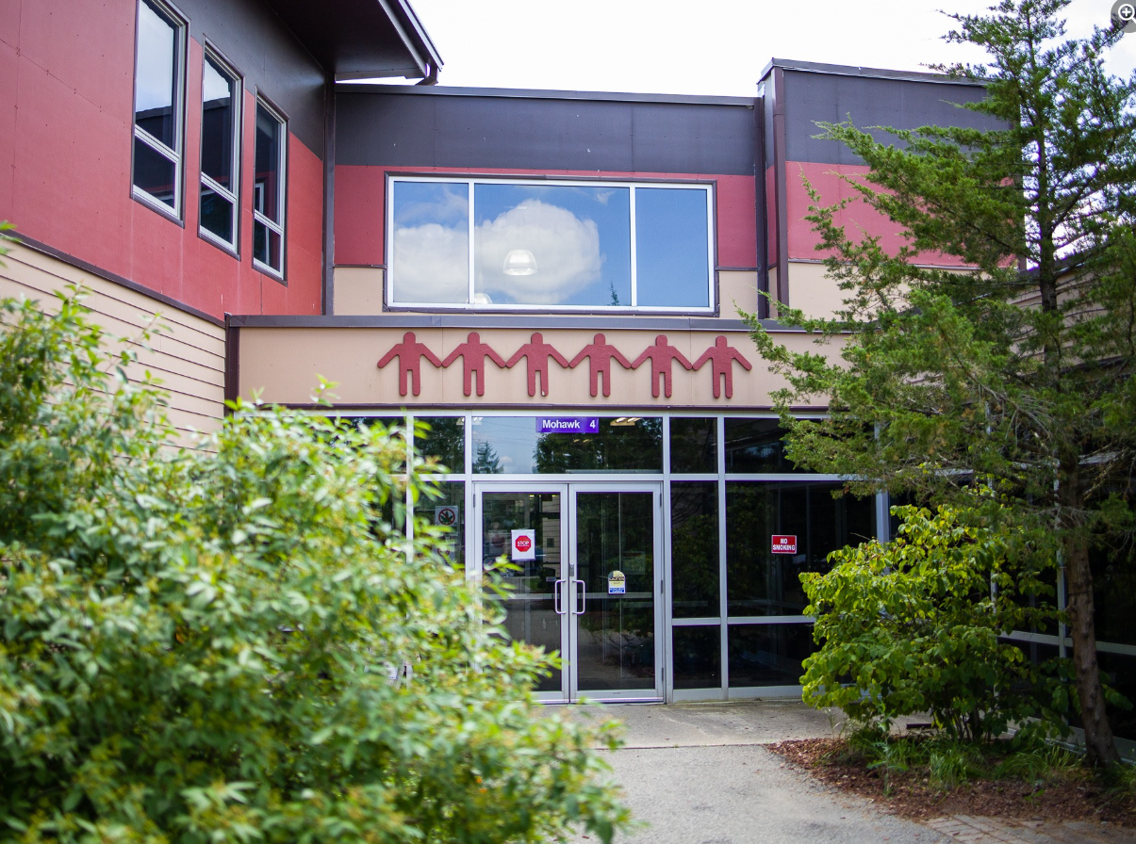
Grand River Employment and Training Inc. (GRETI) is seeking a Student Counsellor to provide supportive, culturally responsive counselling services to students. This role focuses on promoting student well-being, addressing barriers to success, and helping individuals achieve their personal and professional goals.
Student Counsellor
One (1) Full Time Position Available
Salary Range: $53,600 - $75,000

The Student Counsellor shall possess the following skills: Accountability, Dependability, Communication, and Confidentiality. In addition to these skills, you must possess the following qualifications:
Qualifications:
- Diploma in Social Services Worker program or a related discipline
- Three (3) to five (5) years’ experience in counselling, student support, or community services
- Membership with the Ontario College of Social Workers and Social Service Workers is an asset
If you have desire to support student well-being and success through compassionate, culturally responsive counselling practices, tell us who you are by submitting the following:
- Cover letter stating how you meet the demands of this position
- Up to Date Resume highlighting your qualifications, and
- Three (3) work related references (letters not required)
Please submit a covering letter and resume that demonstrates how you meet the requirements, GRETI cannot make assumptions about your education and experience. We thank all those who apply.
GRETI offers a competitive wage, group benefits and pension for full time employees, three (3) weeks’ vacation to start, along with other non-required benefits
Applications must be submitted to: Human Resources, P.O. Box 69, 16 Sunrise Court, Ohsweken, Ontario N0A 1M0
Applications may also be faxed and emailed to (Fax) (519) 445-4777 or kristen@gretisn.org until 4:00 PM on Friday, May 8, 2026.
GRETI is committed to providing an inclusive and barrier-free work environment, starting with the hiring process. If you are contacted by GRETI regarding a job opportunity, please advise if you have any restrictions that need to be accommodated. All information received in relation to accommodation will be kept confidential. Based on the need to provide professional services, only those applicants meeting the minimum qualifications will be contacted for an interview.
Job Title: | Student Counsellor
Location: | Ogwehoweh Skills and Trades Training Centre
Reports To: | Student Services Team Lead

A. PURPOSE:
The Student Counsellor is responsible for providing counselling, guidance, and support services to students participating in courses or training programs. This includes assisting students in addressing personal, social, emotional, and academic challenges that may impact their success. Responsibilities include conducting individual and group counselling sessions, developing student support plans, facilitating workshops, coordinating referrals to community resources, and maintaining accurate documentation.

Student support activities align with OSTTC’s mission by promoting student well-being, strengthening resilience, and enhancing success. The role contributes to creating a culturally supportive environment that reflects and respects the values, traditions, and community of Six Nations, while helping students build the skills needed for personal and professional growth.

The Student Counsellor is responsible for assisting the department and organization in reaching their goals and objectives by continuously enhancing operations through more efficient and effective work processes while maintaining the level of professionalism expected by GRETI (as outlined in the Policies and Procedures Manuals) and upholding the ethics of the position.

B. CORE COMPETENCIES:
- Accountability  - Dependability  - Communication  - Critical Thinking  - Confidentiality | - Ethics & Integrity  - Planning & Organizing  - Problem Solving  - Teamwork  - Group Facilitation
C. QUALIFICATIONS:
The Student Counsellor shall possess Diploma in Social Services Worker program or a related discipline with Three (3) to five (5) years’ experience in counselling, student support, or community services.

Knowledge
- Knowledge of counselling techniques, case management, and student support practices
- Understanding of social, economic, and systemic barriers impacting student success
- Knowledge of Indigenous community, culture, and values, particularly within Six Nations
- Proficiency in Microsoft Office and data management systems

Skills
- Strong interpersonal, facilitation, and communication skills
- Ability to work as part of a multidisciplinary team as well as independently
- Strong organizational, problem-solving, and analytical skills
- Ability to maintain confidentiality and exercise sound professional judgment
- Ability to work flexible hours, including evenings or weekends as required

FOR A COMPLETE COPY OF THE JOB DESCRIPTION, PLEASE CONTACT HUMAN RESOURCES at kristen@gretisn.org, please allow 24 hours for a return
e-mail or call (519) 445-2222 ext. 3113.

We use artificial intelligence tools to support the screening, assessment, and selection of applicants in our GRETI hiring process. These tools assist our team and do not replace human decision-making.

