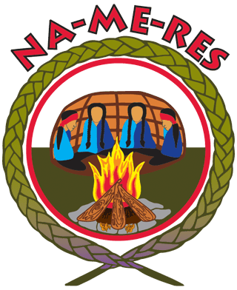
JOB POSTING - Internal/External
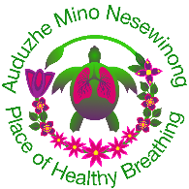
Position: Community Health Worker
Shift: 35hr a week
Salary: $33 per hour
Start: Immediately
Closing: May 7th 2026
Locations: 22 Vaughan Road – Auduzhe Mino Nesewinong
Background
Auduzhe Mino Nesewinong (Place of Healthy Breathing) is an Indigenous-led primary health care initiative that has supported First Nations, Inuit and Métis (FNIM) community members for more than 5 years. Grounded in Indigenous values, self-determination, and relationship-based care, Auduzhe was established to address systemic barriers experienced by FNIM peoples. Through trusted community partnerships and outreach-based service delivery, Auduzhe has grown into an interdisciplinary primary health care model that provides culturally safe, trauma-informed, and wholistic care across the continuum, including health promotion, disease prevention, mental health and wellness, and primary care services. Embedded within Na-Me-Res (Native Men’s Residence), Auduzhe also supports Indigenous men residing at the shelter by delivering culturally safe, trauma-informed primary health care and mental wellness services in a familiar and trusted setting. Auduzhe’s approach prioritizes community-identified needs, continuity of care, and coordination with Indigenous and allied service providers, while advancing Indigenous ways of knowing and being within primary health care settings.

Roles and Responsibilities:
- Provide culturally safe care to First Nations, Inuit, and Métis community members in Tkaronto
- Assist in locating culturally appropriate community resources by liaising with community groups and other health/social service agencies to provide referral information for clients
- Facilitate referrals to other community health center professionals to ensure a care continuum of health and social services
- Work closely with Auduzhe’s medical providers to ensure community members have comprehensive and coordinated care plans
- Provide short term crisis prevention/response, de-escalation, and stabilization through instrumental support and referrals to culturally appropriate crisis services
- Facilitate transportation and/or accompany clients to medical appointments, court, community programs and other appointments as needed
- Establish trusting relationships with FNIM community members and families
- Ensure clients are integrated into the appropriate services both within Auduzhe Mino Nesewinong and wider community as required
- Document on each client contact including services provided/offered including referrals
- Collaborate with one’s service team and other teams across the organization to identify and provide health education to target groups
- Facilitate client referrals to relevant resources
- Provide case support and education to clients
- Job responsibilities and hours are subject to change

Qualifications
- A minimum of 3-5 years’ experience in community-based health care is an asset
- Solid understanding of the issues facing Indigenous communities and systemic barriers to accessing culturally responsive health care
- Excellent knowledge of and ability to apply harm reduction principles and practices in work with the community
- Experience with trauma-informed care; able to communicate with clients in a culturally safe, empathetic, and professional manner
- Experience with Indigenous community-based service; experience in dealing with or knowledge of Indigenous health
- Well-developed and demonstrable experience in crisis management in the mental health/social services field
- Demonstrated knowledge of working with clients with mental health and addiction, including working with groups
- Strong communication (verbal/written) and interpersonal skills
- Ability to work independently and as part of a multi-disciplinary team
- Proficiency in the use of computer technology and using an Electronic Medical Record (EMR)
- Strong organizational skills, attention to detail, and ability to manage multiple tasks in a timely manner and flexibility to adapt to changing workload
- Proof of COVID-19 vaccination

Na-Me-Res encourages First Nation, Inuit, and Métis applicants to apply and please identify in their cover letter and connections to their community. We thank all applicants for their interest, however, only those select for an interview will be contacted. If you are invited to an interview and require accommodation, we will make every effort to accommodate you.

A resume, cover letter, and references can be sent to:
Email: jobs@nameres.org
Fax: (416) 652-3138
Mail: Na-Me-Res (Native Men’s Residence) Human Resources
26 Vaughan Road, Toronto, ON M6G 2C4
(Hand delivered applications will not be accepted)

